**Competition: Design a Christmas Outfit for our Values Ambassador – Lenny Leadership**

Rules:

1. Dress this Values Ambassador in your festive design.
2. Colour, paint, cut and stick or use digital graphics (digital version available).
3. Be creative with the accessories they are holding and give them a seasonal make-over too.
4. One winning design per year group will be used for this year’s PoW Christmas Card. All finished designs will be put on display.
5. **Artwork deadline: Monday 2nd December**

Tip:

* Trace the character onto a blank paper to practice your design first (windows are good for this).

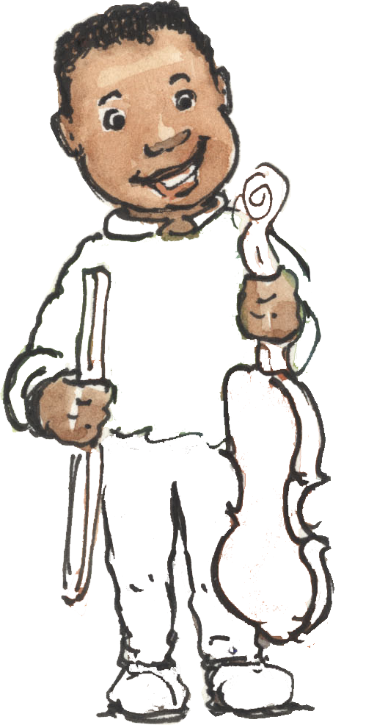

Year 2



Child’s name: _____________

Class: ­­­­­­­­­­­­­­___________________

**Competition: Design a Christmas Outfit for our Values Ambassador – Erin Explore**

Rules:

1. Dress this Values Ambassador in your festive design.
2. Colour, paint, cut and stick or use digital graphics (digital version available).
3. Be creative with the accessories they are holding and give them a seasonal make-over too.
4. One winning design per year group will be used for this year’s PoW Christmas Card. All finished designs will be put on display.
5. **Artwork deadline: Monday 2nd December**

Tip:

* Trace the character onto a blank paper to practice your design first (windows are good for this).

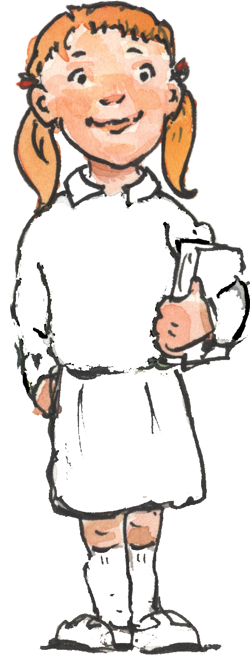

Year 6



Child’s name: _____________

Class: ­­­­­­­­­­­­­­___________________

**Competition: Design a Christmas Outfit for our Values Ambassador – Angelica Appreciation**

Rules:

1. Dress this Values Ambassador in your festive design.
2. Colour, paint, cut and stick or use digital graphics (digital version available).
3. Be creative with the accessories they are holding and give them a seasonal make-over too.
4. One winning design per year group will be used for this year’s PoW Christmas Card. All finished designs will be put on display.
5. **Artwork deadline: Monday 2nd December**

Tip:

* Trace the character onto a blank paper to practice your design first (windows are good for this).

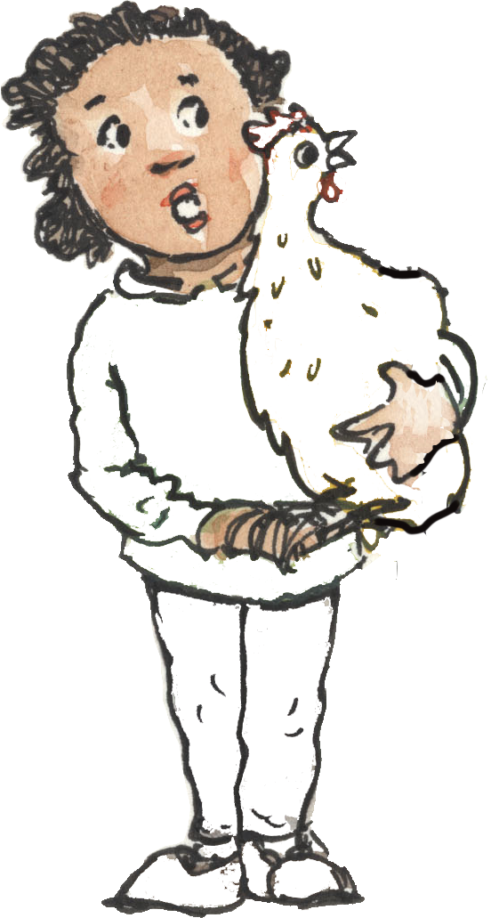

Year 1



Child’s name: _____________

Class: ­­­­­­­­­­­­­­___________________

**Competition: Design a Christmas Outfit for our Values Ambassador – Rahaan Resilience**

Rules:

1. Dress this Values Ambassador in your festive design.
2. Colour, paint, cut and stick or use digital graphics (digital version available).
3. Be creative with the accessories they are holding and give them a seasonal make-over too.
4. One winning design per year group will be used for this year’s PoW Christmas Card. All finished designs will be put on display.
5. **Artwork deadline: Monday 2nd December**

Tip:

* Trace the character onto a blank paper to practice your design first (windows are good for this).

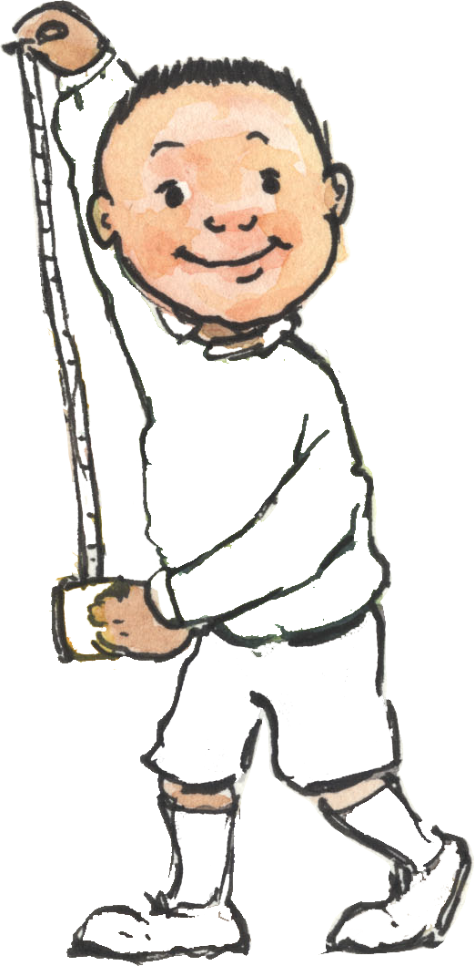

Year 4



Child’s name: _____________

Class: ­­­­­­­­­­­­­­___________________

**Competition: Design a Christmas Outfit for our Values Ambassador – Noah Nurture**

Rules:

1. Dress this Values Ambassador in your festive design.
2. Colour, paint, cut and stick or use digital graphics (digital version available).
3. Be creative with the accessories they are holding and give them a seasonal make-over too.
4. One winning design per year group will be used for this year’s PoW Christmas Card. All finished designs will be put on display.
5. **Artwork deadline: Monday 2nd December**

Tip:

* Trace the character onto a blank paper to practice your design first (windows are good for this).



Year 5



Child’s name: _____________

Class: ­­­­­­­­­­­­­­___________________

**Competition: Design a Christmas Outfit for our Values Ambassador – Ethan Enthusiasm**

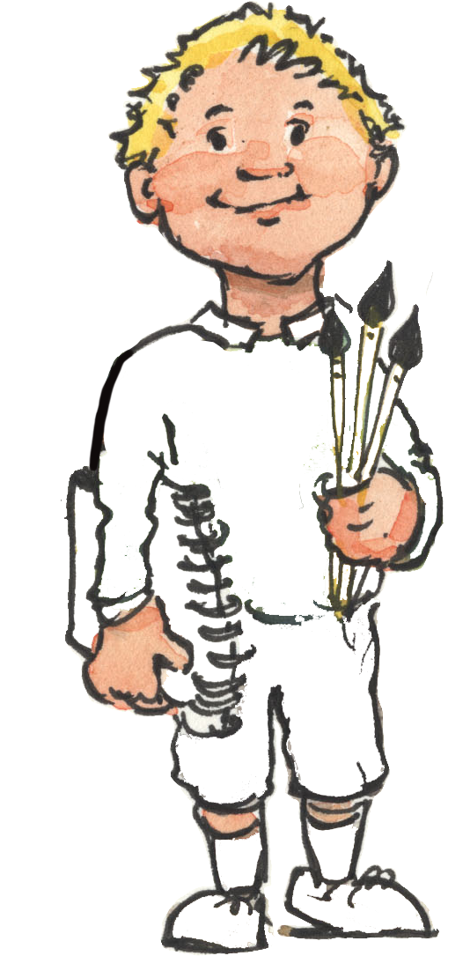

Rules:

1. Dress this Values Ambassador in your festive design.
2. Colour, paint, cut and stick or use digital graphics (digital version available).
3. Be creative with the accessories they are holding and give them a seasonal make-over too.
4. One winning design per year group will be used for this year’s PoW Christmas Card. All finished designs will be put on display.
5. **Artwork deadline: Monday 2nd December**

Tip:

* Trace the character onto a blank paper to practice your design first (windows are good for this).

Reception



Child’s name: _____________

Class: ­­­­­­­­­­­­­­___________________

**Competition: Design a Christmas Outfit for our Values Ambassador – Reyha Reflection**

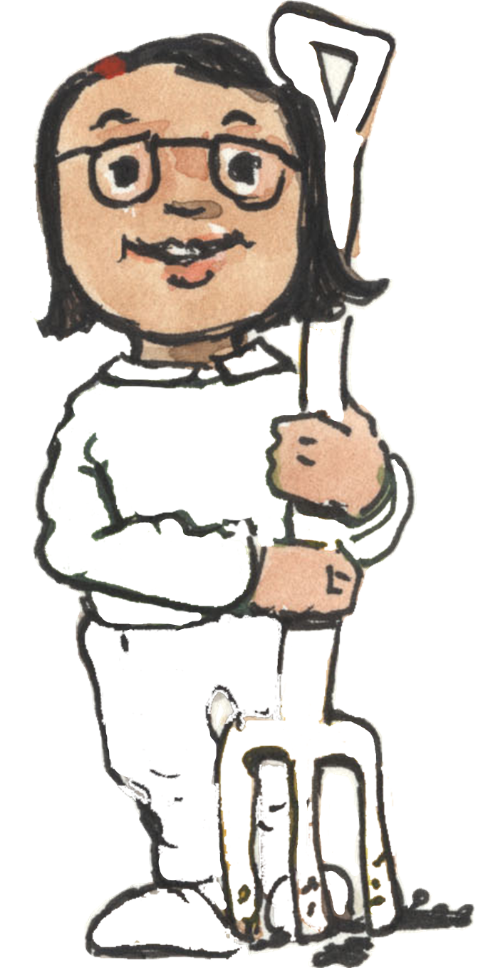

Rules:

1. Dress this Values Ambassador in your festive design.
2. Colour, paint, cut and stick or use digital graphics (digital version available).
3. Be creative with the accessories they are holding and give them a seasonal make-over too.
4. One winning design per year group will be used for this year’s PoW Christmas Card. All finished designs will be put on display.
5. **Artwork deadline: Monday 2nd December**

Tip:

* Trace the character onto a blank paper to practice your design first (windows are good for this).

Year 3



Child’s name: _____________

Class: ­­­­­­­­­­­­­­___________________

**Competition: Design a Christmas Outfit for our Values Ambassador – Sonia Sustainability & Reflection**

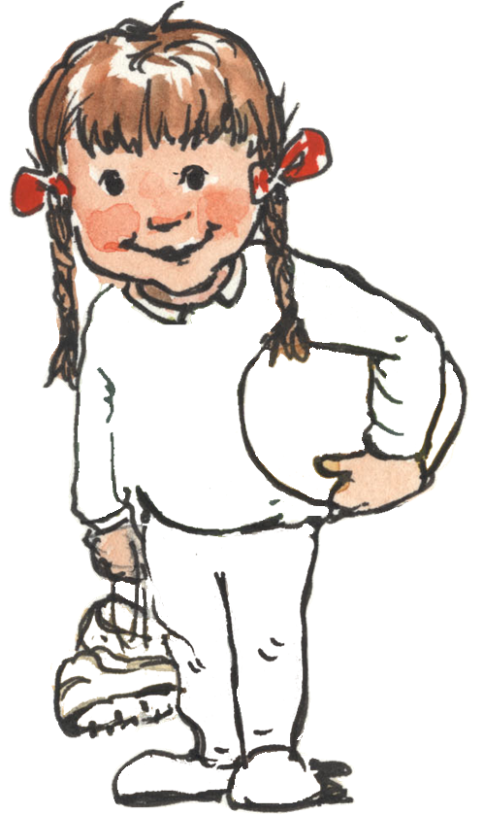

Rules:

1. Dress this Values Ambassador in your festive design.
2. Colour, paint, cut and stick or use digital graphics (digital version available).
3. Be creative with the accessories they are holding and give them a seasonal make-over too.
4. One winning design per year group will be used for this year’s PoW Christmas Card. All finished designs will be put on display.
5. **Artwork deadline: Monday 2nd December**

Tip:

* Trace the character onto a blank paper to practice your design first (windows are good for this).

Nursery



Child’s name: _____________

Class: ­­­­­­­­­­­­­­___________________